# 

Figure 1

# Methods and Materials

## Participants

A total of 45 healthy adults participated in our study. 3 participants (2 males and a female of 3 nationalities, 30±5, mean±SD) worked as models for the capture of human arm motion data. 42 participants (20 Males and 22 females of 12 nationalities, 25.9±4.35, mean±SD, min. age 20, max. age 39), were participated as ‘co-workers’ in our main experiment. 3 out of 46 participants were left-handed according to the *Edinburgh Handedness Inventory,* and all participants had normal or corrected to normal vision. The experiments were approved by the local ethics committee at the National Institute of Advanced Industrial Science and Technology (AIST) in Tsukuba, Japan, and all participants read and signed an informed consent form before taking part in the experiments. Participants were naïve to the motives of the experiments and received 2021 JPY to participate.

## Setup

The participant and co-worker (a human or a humanoid robot) were seated on a chair with tables facing each other as shown in the experiment setup (Fig. 2). On a horizontally placed touch-screen (23-inch HD DELL, P2314T) on the table, participants were presented with two red circles of diameter Ø5 cm at distance of 50 cm from each other. The co-worker was similarly presented with two red circles on black cardboard Ø9 cm at distance of 50 cm. The whole setup was enclosed by movable panels and the panel behind the co-worker was covered with a dark grey curtain.

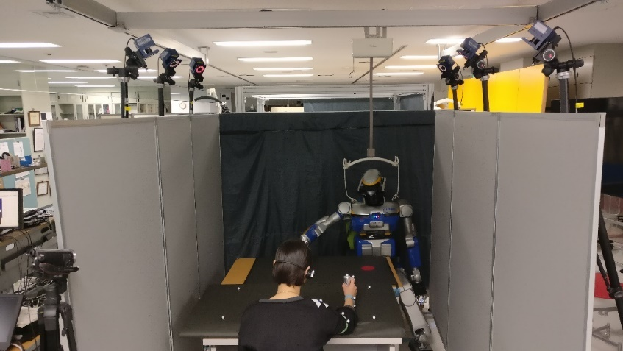

Figure 2

A motion tracking system (*Motion Analysis**Co.*) with six infrared cameras (kestrel) and ten passive markers were used to record the arm motions of the participant and co-worker at 200Hz.

A bipedal HRP2-Kai humanoid robot (154cm tall, 58kg, 32 DOF) was used as the robot co-worker (Fig. 2). A well-trained experimenter (M, 37) acted as the human co-worker. Both co-workers used their right arm throughout the experiment.

### Experimental task and conditions

Motivated by the hand movements during an industrial pick-n-place task. Participants were required to repeatedly touch two static red circles on the touch-screen with a stylus in their right hand during the task. A co-worker (human or HRP-2Kai) worked on the same task in front of the participants. The participants worked in a series of 50 second *trials* with the co-worker. In a trial, participants initially performed alone for 10 seconds (participant-alone period), performed with the co-worker for next 20 seconds (together period) and then relaxed while watching the co-worker performs the task for the last 20 seconds (co-worker-alone period) (Fig. 3).

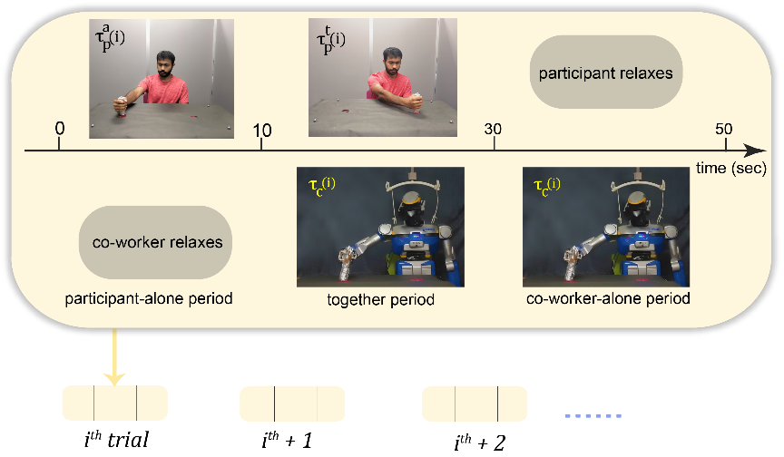

Figure 3

All participants wore ear buds and headphones (through which we sent white noise) and had no external audio feedback (confirmed in the post experiment questionnaire). They were instructed to “*always* *hold the stylus like a stamp* and *touch alternatively inside each red circle on the touch-screen with continuous and smooth hand movements at a comfortable speed*”. They were specifically told to “*focus on your own task and ignore the co-worker when he/it starts after them*”. No instructions were given regarding the speed and movement trajectory.

We studied six experimental conditions. The participants worked with a robot co-worker in four conditions, specifically *robot co-worker* (**RV**)*, robot covered co-worker* (**RC**)*, robot non-biol* (**RN**)and *robot indus* (**RI**). In the remaining *human co-worker* (**HV**) and *human covered co-worker* (**HC**) conditions, they worked with a human co-worker. The HRP-2Kai robot played back the recorded (biological) hand movements in the **RV, RC** conditions. The robot movements in the **RN** condition was ‘non-human’ in nature (see details in section *robot movement trajectories*). The **RI**condition is out of scope of this study.

The participants were randomly assigned to one of the seven groups (see Table 1). During experiment, each participant worked in the **RV** condition and two of the remaining five conditions, allowing us to compare their behavior in any condition to with his behavior in the **RV** condition. The order of the conditions was randomized across participants in each group.

|  |  |  |  |  |  |  |  |
| --- | --- | --- | --- | --- | --- | --- | --- |
| Groups | G1 | G2 | G3 | G4 | G5 | G6 | G7 |
| Session 1 | *robot-co-worker* | | | | | | |
| Session 2 | *robot indus* | *robot covered co-worker* | *human co-worker* | *robot covered co-worker* | *human co-worker* | *robot covered co-worker* | *robot covered co-worker* |
| Session 3 | *robot non-biol* | *robot indus* | *human covered co-worker* | *human covered co-worker* | *robot non-biol* | *human co-worker* | *robot non-biol* |

Table 1. Experimental Groups

Each condition had 10 trials. The co-worker performed at a constant, unique, pseudo-randomly selected frequency (in the range of 0.16 to 1.1 Hz) in each trial. The pseudo-random nature of the co-worker performance was critical to avoid behavioral drift contamination across trials. The human co-worker was provided with a metronome using earphones (like in Bisio et al.), to cue and help maintaining the movement frequency.

### HRP-2Kai movement trajectories

The biological movements played on HRP-2Kai in **RV** and **RC** conditions were a playback of the human arm movements (Fig. 4, blue plot) recorded in a preliminary experiment with three volunteers using same (Motion Analysis Co.) motion tracking system, while the human movements were cued by an audio metronome. Movements were collected at several frequencies between 0.16 to 1.1Hz. We found the movements of the three volunteers to be statistically similar in the x, y and z velocity profiles (p > 0.05), and showing similar trend in movement height with movement frequency --trajectory height consistently decreased with increase of movement frequency. We therefore chose to use the movements recorded from one volunteer (a male) in this experiment.

Well learnt human movements are characterized by a bell-shaped velocity profile. The peak of the bell-shaped profile may be shifted forward in time when precision is required at the reach end (like in our task when the participants required to touch inside a given target region), but the velocity profile is normally characterized by a single peak. Therefore, here we used a trajectory with three distinct velocity peaks (cyan plots in Fig. 4 and Fig. 5. C, D) as a candidate ‘non-biological’ movement profile in the **RN** conditions. Since our task is inspired by the hand movements during an industrial pick-n-place task, to have a smooth transition, we chose to design **RN** (*robot non-biol*) *as* piecewise polynomial trajectory by fusing a 5th and 3rd order polynomials divided into three segments (*lift-off*(l)*, carry*(c)*, set-down*(s)) [1]. In (Fig. 5) initial () and final () time instants, , and are the time crossing at via-point 1 and via-point 2 respectively. We restricted our task movements in YZ plane therefore, the piecewise polynomial trajectory was mainly design in y(horizontal) & z(vertical) direction while x was always kept constant zero.

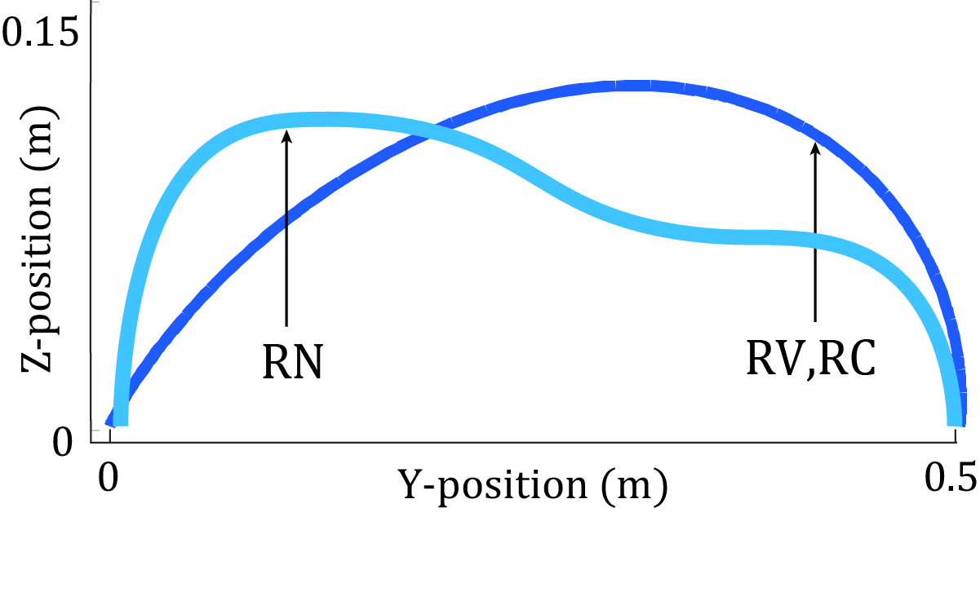

Figure 4

In movement direction (Y-axis), for 5-5-5 order piecewise trajectory, total of 18 parameters were computed,

|  |  |  |
| --- | --- | --- |
|  |  | (1) |

|  |  |  |
| --- | --- | --- |
|  |  | (2) |

|  |  |  |
| --- | --- | --- |
|  |  | (3) |

Boundary conditions would be given by

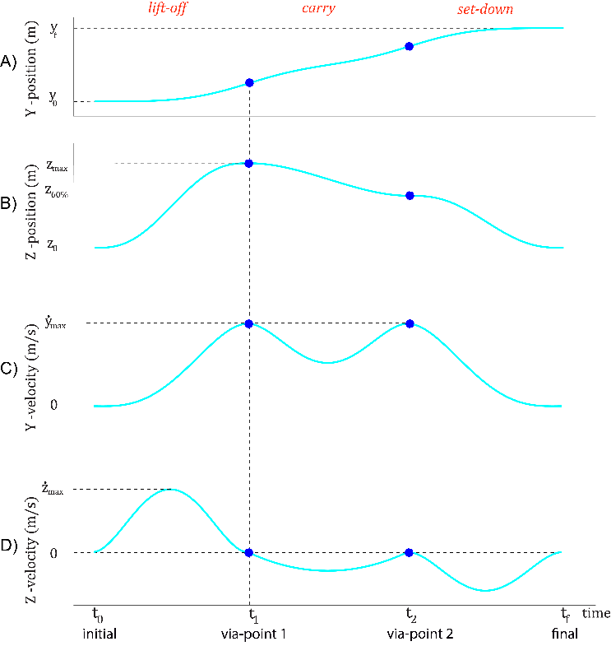

Figure 5. In YZ plane, Positions of Robot-non-biol ‘5-3-5’ (lift-off(l), carry(c), set-down(s)) trajectory, blue circles represent via- points

*4 crossing conditions,*

*6 initial and final conditions*

*6 continuity conditions for velocity, acceleration and jerk*

= (*tuning parameter*)

= (*tuning parameter*)

Where, , to maintain shape of trajectory, desirable to be played on HRP2-kai,

using above boundary conditions, we calculated the parameters in (Eq. 1, 2, 3)

*During Lift-off (l)*

*During Carry (c)*

*During Set-down (s)*

In direction perpendicular to movement direction (Z-axis), for 5-3-5 order piecewise trajectory, total of 16 parameters were computed,

|  |  |  |
| --- | --- | --- |
|  |  | (4) |

|  |  |  |
| --- | --- | --- |
|  |  | (5) |

|  |  |  |
| --- | --- | --- |
|  |  | (6) |

Boundary conditions would be given by,

*4 crossing conditions,*

*6 initial and final conditions*

*4 continuity conditions for velocity and acceleration*

Where, is 60% of ,

using above boundary conditions, we calculated the parameters in (Eq. 4, 5, 6)

*During Lift-off (l)*

*During Carry (c)*

*During Set-down (s)*

## Data Analysis

### Variables

Our analysis is based on the position data of both participant’s and co-worker’s stylus markers. Since their movements were oriented in the YZ plane. To extract out possible behavioral differences between the movements towards and back, between the touch points, we analyzed behavioral variables across each movement between the red circles on the touch-screen, which we call as iterations. As participants and co-workers were required to make non-stop continuous movements between touches, we could extract individual iterations of participant’s and co-worker’s by looking for changes in the direction of y-velocity in the recorded motion capture data. We were interested in the change in performance of participants, therefore we primarily concentrated on the time between the touches in each iteration (iteration duration), which we will refer to as the half-time period (*htp*) or . In addition, we also analyzed kinematic variables along the Y(horizontal) and Z(vertical) axes inside each iteration of them and analyzed the maximum movement length maximum movement height maximum absolute velocities mean absolute velocities minimum accelerations maximum accelerations however results of which are out of scope of this study.

### Quantifying the induced motor contagion

We quantified participants change in behavior after observing the co-worker, by analyzing at how the average value of a given time variable by a participant is changed in the together period in a trial *i*. As the trials were divided into 3 blocks (Fig. 3), the first 10 seconds when participants performed alone (participant-alone period) , next 20 seconds when they performed with the co-worker (together period) , and in the last 20 seconds they relaxed while watching the co-worker perform its/his task . Notice here, to remove any persistent induced effect during the participant-alone period , we specifically analyzed the change in the participants behavior, between the together period and alone-period in a trial () and the corresponding value of the same variable in the co-worker behavior in the same trial where , the average undisturbed *htp* across trials during participant-alone period.

Since the co-worker’s was random across trials, therefore participant’s were arranged in increasing order w.r.t. coworker’s on the abscissa. To find out how much contagion has induced, a first or second order regression model was chosen based on Akaike Information criteria (AIC) [2] with lowest value and regression fitting models were created using MATLAB’s fitlm function for each participant. The tangent slope at the minimum co-worker variable value (]) was collected across participants, checked for normality using the *Shapiro-Wilk* test and then analyzed for difference from zero using a one-sample *T*-test or a *Signed Rank* test. The fitting of *htp* in representative participants in the five reported conditions are shown in Fig. 1B and Fig. 6 and the collection of slopes are in shown in Fig. 1D.

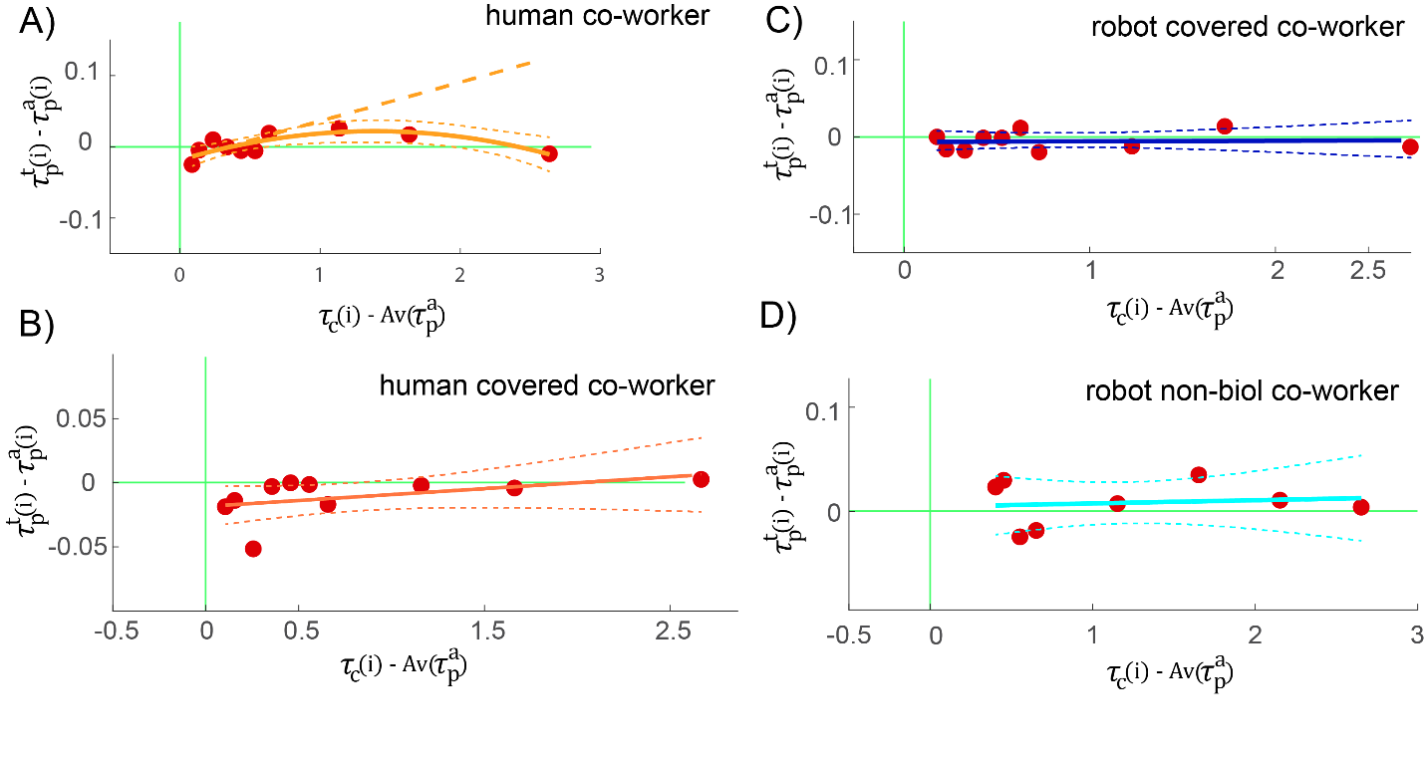

Figure 6

### ~~Movement position variance~~

~~How did we do it ?~~

### Statistical correction

As reported earlier, every participant in our study participated in three conditions: the **RV** condition, and two of the remaining conditions. We thus compare the behavior of the participant in any condition with the **RV**,and use a correction of (3 conditions − 1) 2, and hence a statistical significance threshold of 0.05/2 = 0.025, in the statistics wherever a comparison is reported.

## Results and Discussion

Notice that initially we recruited 35 participants (inclusive 3 outliers, 95% C.I.), all of whom performed in the **RV**condition, with 13 participants performing each of the**RC***,* **HV***,* **HC***,* and **RN** conditions. Since the slope distribution of *htp* across the participants in **RV** condition was found significantly positive therefore, we believed to find similar significance in the *sample* slope distribution of **RV** condition when considered only participants who participated in the **RV** and one of the rest conditions However, we failed to see significance in and )sample slope distributions, therefore we later added 7 more participants in **RC** and **RN** conditions (see Table 1( G7)) to get significance in the **RV** condition sample slope distributionacross

~~where RV is~~~~the~~ *~~robot co-worker~~* ~~condition slope distribution grouped with (~~*~~human co-worker~~* ~~(HV)~~*~~, robot covered co-worker~~*~~(RC)~~*~~, human covered co-worker~~*~~(HC) and~~ *~~robot non-biol~~*~~(RN)) conditions respectively~~

Moreover, our majority of slopes distribution were non-parametric, therefore one-way *Kruskal-Wallis* H-test was performed on the slopes distribution of each condition and found significant difference between conditions *.*

Group wise, another one-way *Kruskal-Wallis* H-test was performed to check whether our main condition robot co-worker across participants varied between conditions, as expected no significant difference was found in (see Table 1 for more details).

### Co-worker’s behavior improves participant’s performance

In **RV** condition, the slope distribution was found highly significant and positive across participants , we also found similar result in **HV** condition where slope distribution was highly significant and positive across participants , moreover, this third quadrant results as an *improvement* in participant performance induced by the presence of ~~the human as well as~~ a robot co-worker because, the participant movement frequency increased (relative to their performance frequency alone).

Note that we did not find any significant effect when both robot and human co-worker body except right arm was covered in **RC** and **HC** conditions, also when robot movements violated biological laws of motion such as here in **RN**  These results support our hypothesis that the humanoid form as well as biological motion are required for induction of the contagion.

It is also interesting to highlight while these above conditions failed to induce contagion in the participants performance, we also found significant slopes difference between our main condition **RV** and other conditions. Condition wise, 3 T-test was performed on the slope difference between **RV vs RC RV vs HC RV vs RN** @Ashesh🡪 change diff p values in main focus

Another T-test was performed on the slopes difference of **RV** condition, and their corresponding participants in **HV** condition, **RV vs** **HV**, . This result strengthens our hypothesis that humanoid appearance robot can in fact induce contagion and improve human performance, but only when generated movements obey biological laws.

### Increase in performance but not in movement variance

It is often possible to achieve increase in performance at a cost of increase in movement variance. To measure how much participant’s touch position varied in each trial, we recorded participants touch positions (X, Y coordinates inside red circles) using MATLAB’s ginput function. Since touch-screen was rectangular (51cm x 29cm), the circles were placed diagonally such that their center distance would not exceed 50 cm. It is worth mentioning, while the participants performance was affected (frequency increased) when they worked with robot co-worker, no such trend was observed in the participants touch behavior, the participant maintained the touch positions () variance between when they worked alone and when they worked with the robot co-worker, showing that the robot did not affect their task accuracies. In order words with the increase in performance we found no visible effect on their movement accuracy.

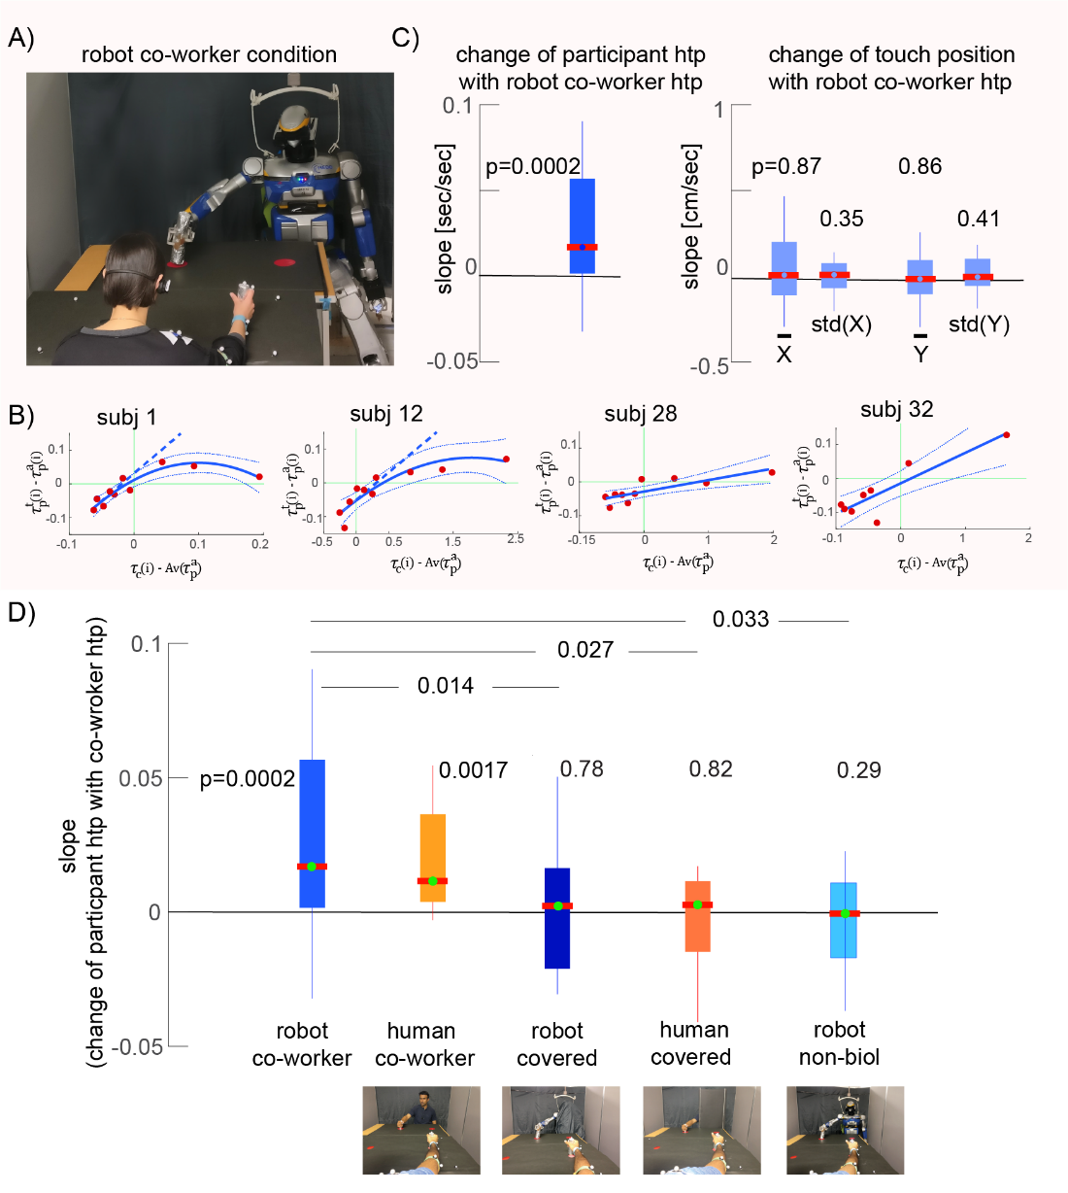

Figure 7

### Performance doesn’t degrade with experience

In **RV** condition*,* we divided total participants population (N = 39) into three blocks (B1(13) person from technical background (*tech*ie), B2(11) person being aware of robots, they may have seen in shops or museums or participated before in some HRI experiments (*non-techie*), B3(15) *novice*) based on their level of technical experience in the domain of science and engineering. Interestingly within our participants, the effect was observed to be stronger in participants with robot experience, compared to those without (Fig. 8), suggesting that the effect we show does not reduce with robot experience (*novice* < *non-techie* < *techie* One-way *Kruskal-Wallis* H-testrevealed no significant difference between blocks B1, B2 and B3 .

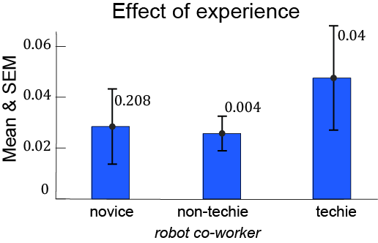

Figure 8

### Zero crossing- selecting appropriate regression model

Since slope of the tangent on the starting point (]) of regression models were considered as criteria to measure induced contagion but in many participants this related increase in *htp*s had a threshold after which the participants *htp*s decreased and one could argue here the significance of using second order regression model irrespective of AIC, therefore we looked for point on abscissa at which the direction of slope changes from positive to negative (y=0 crossing, first derivative of regression model). In each condition, we found the point of zero crossing on abscissa to be after second, which is at 70% of the total played frequencies between 0.16 to 1.1Hz by the co-workers (Fig. 9).

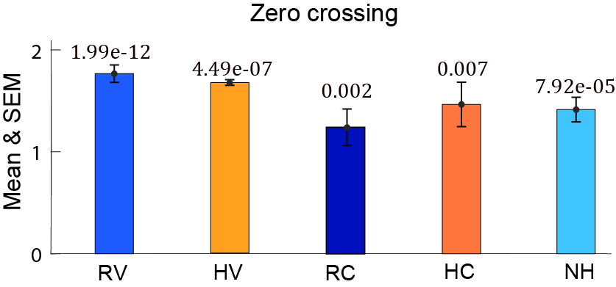

Figure 9

### Post experiment questionnaire (incomplete)

Since in our experiment, we believed that making the robot’s performance frequency higher (*htp* shorter) led to an increase in participants performance frequency (decrease in *htp*) without them consciously perceiving it. To verify our statement that this change in behavior (improve in performance) of participants is implicit and in no way explicit, in Experiment 2, a short questionnaire was designed to understand the state of mind of the participants and if they were aware of the effect induced by the co-worker during experiment. Following questions were prepared for each session and participants had to choose their most plausible answer on a scale of 0 to 7, where 0 (Not at all), 7 (very strongly)

1. My movements were affected when the agent was working with me.
2. My movement speed was changed when the agent was working with me.
3. I was tired during the experiment.
4. I could maintain the movement speed that I wanted even when the robot was performing its task.
5. I found it difficult to do my task when the agent was working with me.

We took average of question 1, 2 and 4, as they meant to convey same meaning which is if participants felt their behavior was influenced by the co-worker. Question 3, also ruled out the possibility which one could argue that their decrease in performance as co-worker’s *htp* gets longer may be because of being tired during the experiment. (Fig. 10) show (mean±SD) of questions answered by participants. Which clearly favors our belief that their increase in performance happened implicitly.

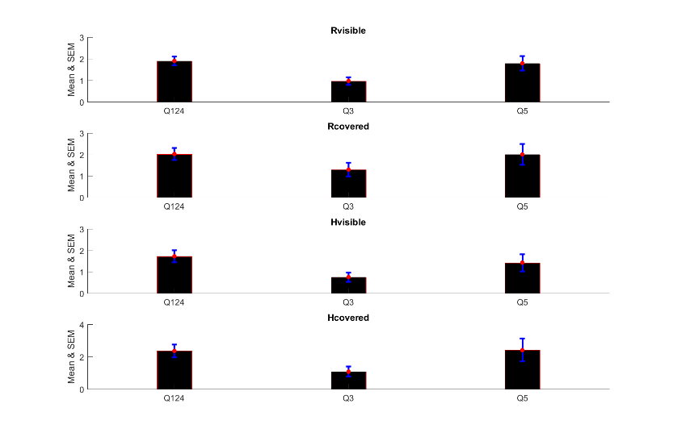

Figure 10

# References

1. L. Biagiotti, C. Melchiorri, *Trajectory planning for automatic machines and robots* (Springer Berlin Heidelberg, 2009).
2. H. Akaike, Information theory and an extensión of the maximum likelihood principle. International symposium on information theory, 267–281 (1973).